**2.1 Sensation vs Perception**

* Sensation → raw signal, which is unfiltered and unprocessed until it enters the CNS
* Perception → processing of this info to make sense of its significance

Sensory Receptors

* Sensory receptor → afferent neuron → sensory ganglion → spinal cord → brain (projection areas)
* Two types of stimuli:
  + **Distal** stimuli originate outside of the body
    - E.g. campfire
  + **Proximal** stimuli interact directly with and affect the sensory receptors and inform the observer about the presence of distal stimuli
    - E.g. photons that reach the observer’s cones and rods, the heat the observer feels

1. Photoreceptors: respond to electromagnetic waves in the visible spectrum (**sight**)
2. Hair cells: respond to **movement** of fluid in the inner ear structures (hearing, rotational and linear acceleration)
3. Nocireceptors: respond to **painful** or noxious stimuli (somatosensation)
4. Thermoreceptors: respond to changes in **temperature** (thermosensation)
5. Osmoreceptors: respond to the **osmolarity** of the blood (water homeostasis)
6. Olfactory receptors: respond to volatile compounds (**smell**)
7. Taste receptors: respond to dissolved compounds (**taste**)

Thresholds

1. Absolute Threshold
   1. Minimum intensity at which a stimulus will be **transduced** (converted into action potentials) → how bright, loud, or intense a stimulus must be before it is sensed
   2. Does not reach higher-order brain!
2. Threshold of Conscious Perception
   1. Minimum amount of stimulus energy that will create a signal large enough in size and long enough in duration to be brought into **awareness**
3. Difference Threshold (or just-noticeable difference)
   1. Minimum difference in magnitude between two stimuli before one can perceive this difference
   2. **Weber’s law**
      1. jnd is proportional to the magnitude of the stimulus
      2. This proportion (**ratio = diff/ original**) is constant over most of the range of possible stimuli (except at the extreme ends)
      3. E.g. jnd for sound freq = 0.68% (3/440 = 6.8/1000 =...)
         1. Can hear sound diff between 440Hz and 443Hz
         2. Can hear sound diff between 1000Hz and 1006.8 Hz
         3. Cannot hear sound diff between 1000Hz and 1003Hz

Signal Detection Theory

* Refers to the effect of **nonsensory factors** e.g. experiences, motives, and expectations, on perception of stimuli
* Depends on internal (psychological) and external (environmental) context
* Experiments - catch trials (signals present) and noise trials (signals absent) - allow us to look at **response bias** → hits, misses, false alarms, correct negatives

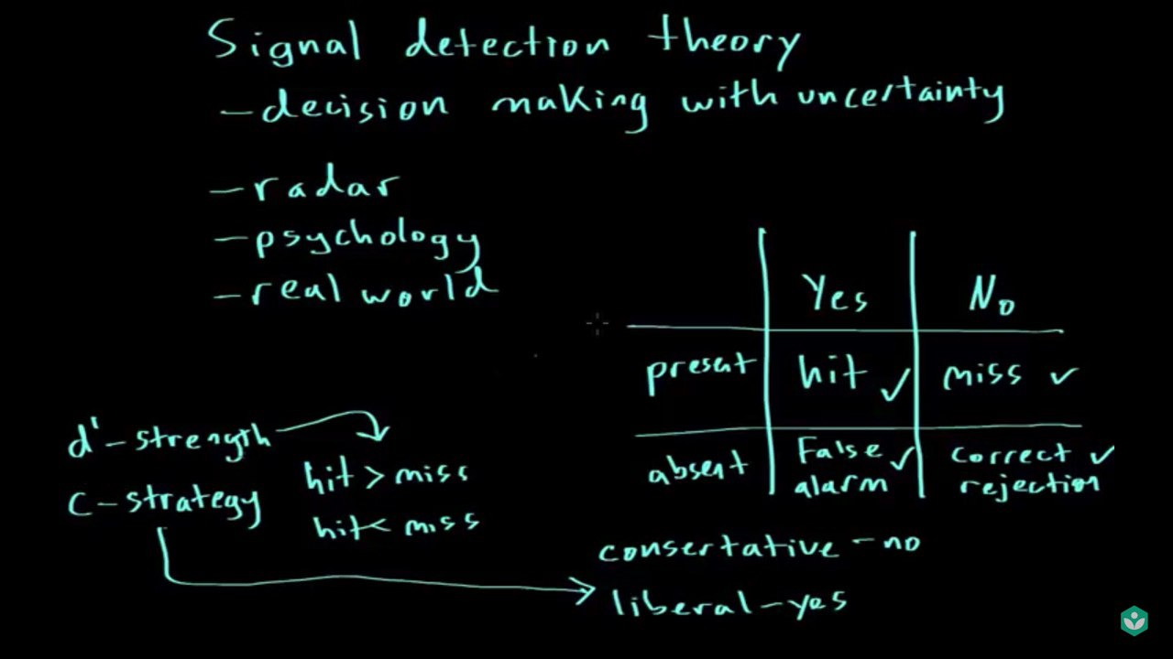

1. Strength (d’) e.g. of the green traffic light
   1. Strong: more hits than misses
   2. Weak: more misses than hits
2. Strategy (c)
   1. Conservative: more likely to say “no” (marked by the “No” column of the table)
   2. Liberal: more likely to say “yes” (marked by the “Yes” column of the table)

Adaptation

* Decrease in response to a stimulus over time → might increase Difference Threshold
  + The stimulus should be **constant**
* Can have a physiological (sensory) component
  + Pupils will dilate in the dark, and will constrict in the light → make our vision more similar in different environments
* Can have a psychological (perceptual) component
  + Once we are dressed, we stop feeling the clothes on our bodies until we have a reason to think about them

**2.2 Vision\***

Structure and Function of the Eye

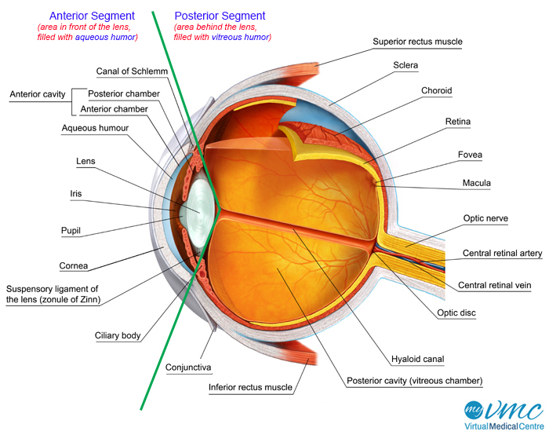

* **Sclera**: thick structural layer; white part of the eye
* **Cornea**: frontmost transparent portion that covers the iris, pupil (opening in the centre of iris) and anterior chamber; gathers and filters incoming light
* **Choroidal** and **Retinal** blood vessels: supply nutrients
* **Iris**: colored, ringed part of the eye, and consists of two muscles:
  + **Dilator pupillae**: opens the pupil under sympathetic stimulation
  + **Constrictor pupillae**: constricts the pupil under parasympathetic stimulation
* **Ciliary body**: produces the aqueous humor that bathes the front part of the eye before draining into the **canal of Schlemm**
* **Lens**: Lies right behind the iris, and controls the refraction of the incoming light
* **Ciliary muscle** (part of ciliary body): contraction is under parasympathetic control → pulls on the **suspensory ligaments** and changes the shape of the lens (known as **accommodation**)
* **Retina**: the innermost layer of the eye; contains photoreceptors that transduce light into electrical information
  + **Co**nes: **Co**lour vision (RGB)
    - Macula: Central section of the retina (contains high conc of cones)
    - Fovea: Centremost point (contains only cones)
  + Rods: Light and dark
    - More rods than cones in the human eye
    - As one moves further away from the fovea, the conc of rods increases while the conc of cones decrease
* Rods and cones synapse on **bipolar cells**, which synapse on ganglion cells. Integration of the signals from ganglion cells and edge-sharpening is performed by **horizontal** and **amacrine** **cells**.
* The resolution decreases as the number of receptors that converge through the bipolar neurons onto one ganglion cell increases
* Less cones converge than rods → colour vision has greater sensitivity to details

Visual Pathways

* Eye → optic nerve → optic chiasm → optic tracts → lateral geniculate nucleus (LGN) in thalamus → visual cortex (through visual radiations)
* There are also inputs into superior colliculus → controls some responses to visual stimuli and reflexive eye movements

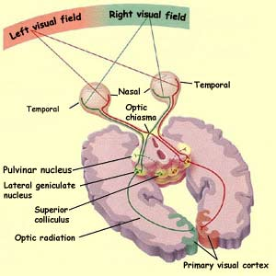

Processing

* Vision is processed through **parallel processing**: the ability to simultaneously and combine information regarding:
  + **Co**lour: detected by **cones**
  + Shape: detected by **parvocellular cells** (high spatial resolution, low temporal resolution)
  + **M**otion: detected by **magnocellular cells** (low spatial resolution, high temporal resolution)

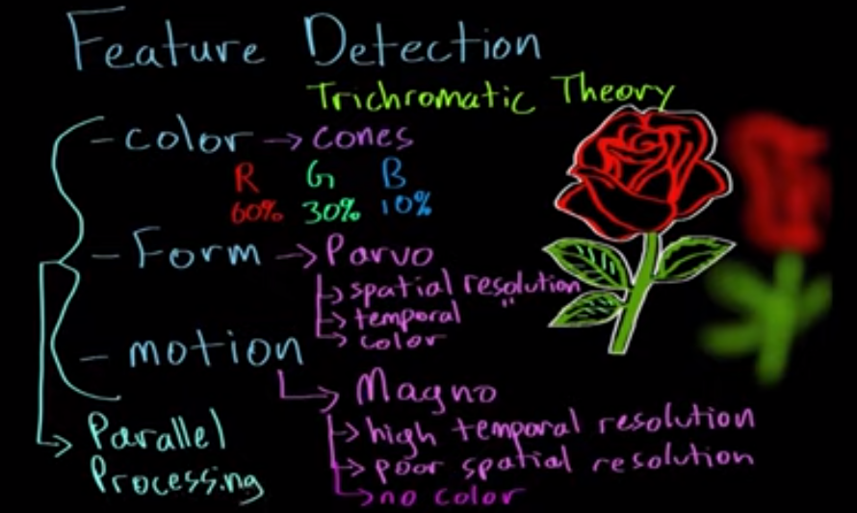

**2.3 Hearing and Vestibular Sense**

* Vestibular sense = sense of rotational and linear acceleration

Structure and Function of the Ear

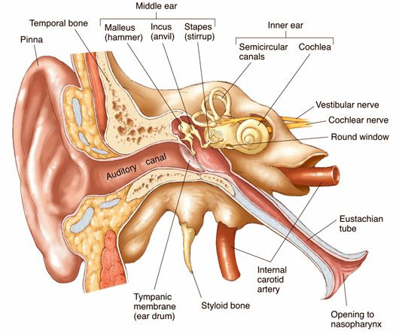

* Outer ear: pinna (auricle), external auditory canal, and tympanic membrane
* Middle ear: ossicles (malleus, incus, stapes); connected to the nasal cavity by the **Eustachian tube**
* Inner ear
  + Bony labyrinth (filled with **perilymph**)
    - Cochlea: detects **sound**
      * contains the **organ of Corti**, which contains hair cells that can convert the physical stimulus into an electrical signal → auditory (vestibulocochlear) nerve → CNS
    - Vestibule: detects **linear** acceleration
      * Contains **utricle** and **saccule** (modified hair cells covered with otoliths) → resist that motion when body accelerates → bends and stimulates the underlying hair cells → send a signal to the brain
    - Semicircular canals: detects **rotational** acceleration
      * Contains the **ampulla**, where the hair cells are located
      * When the head rotates, endolymph in the semicircular canal resists this motion → bends the underlying hair cells → sends a signal to the brain
  + Membranous labyrinth (filled with **endolymph**)
    - Continuous system of ducts filled with endolymph

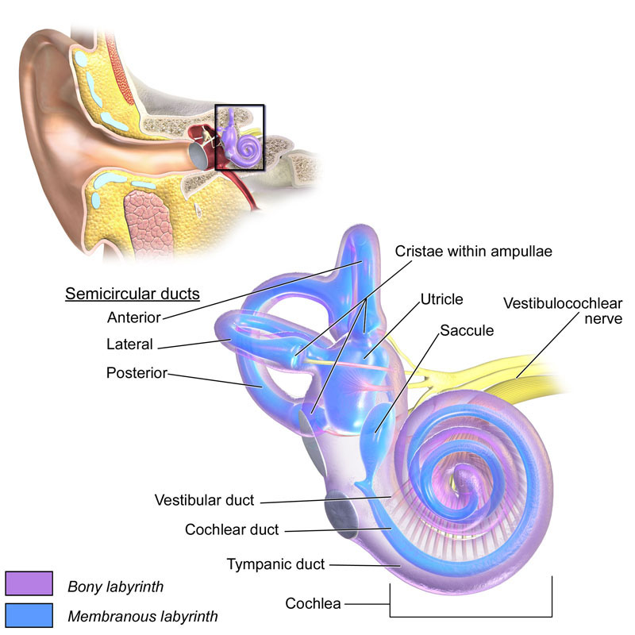

Auditory Pathways

* Sound information: pinna → external auditory canal → tympanic membrane → malleus → incus → stapes → oval window → perilymph in cochlea → basilar membrane → hair cells → vestibulocochlear nerve → brainstem → medial geniculate nucleus (**MGN**) of the thalamus → auditory cortex in the temporal lobe (for sound processing) → superior olive (sound localization) and inferior colliculus (vestibulo-ocular reflex to keep eyes fixed on a point when the head is turned)

Hair Cells

* Movement of fluid → hair cells move → opens the ion channel → depolarization
* Place Theory
  + The location of a hair cell on the basilar membrane determines the perception of pitch when that hair cell is vibrated (i.e. cochlea is **tonotopically organized**)
  + Vibrations close to oval window → higher freq pitch; vibration at apex (near oval window) → lower freq pitch

**2.4 Other Senses\***

Smell

* Nostril → nasal cavity → olfactory chemoreceptors (olfactory nerves) on olfactory epithelium in the upper part of the nasal cavity → olfactory bulb → olfactory tract → higher-order brain regions, including limbic system

Taste

* Five tastes: Sweet, sour, salty, bitter, unami (savoury)
* Chemoreceptors (taste buds) on papillae → brain stem → taste center in the thalamus → higher-order brain regions
* This is the correct version: Each taste bud is composed of multiple cells, that combine to sense 1 of the 5 flavors

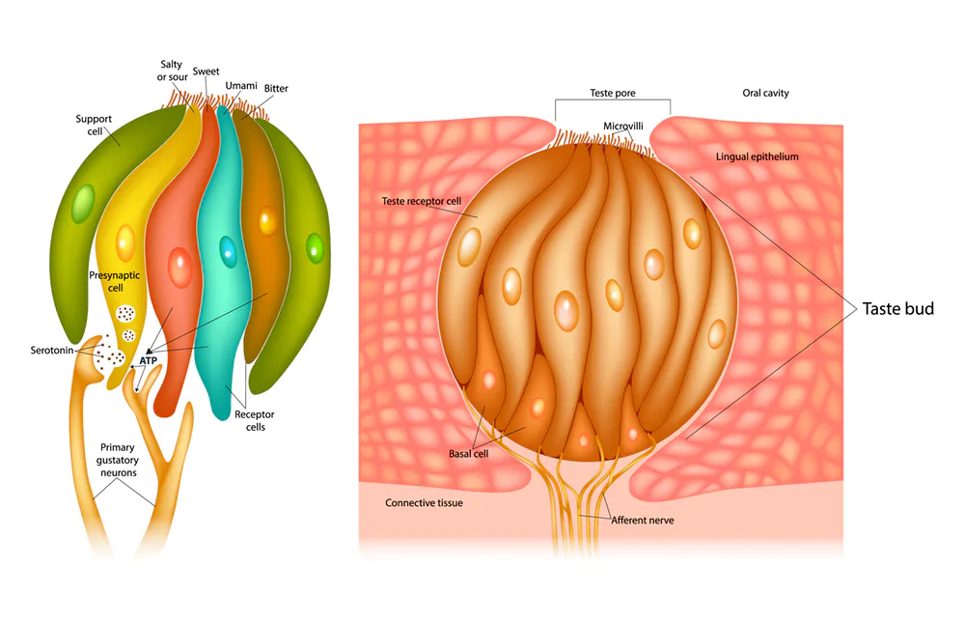

* Our tongue is **NOT** divided into different regions of taste bud types

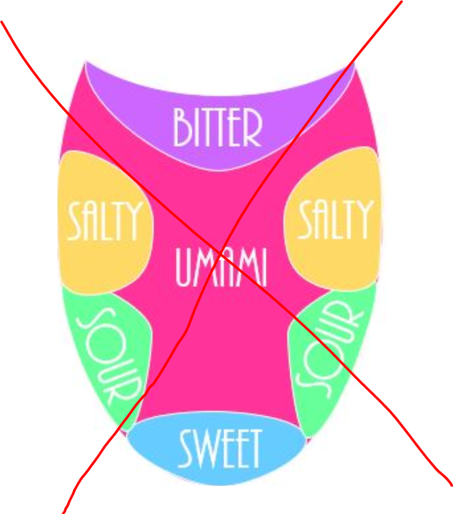

Somatosensation

* Four touch modalities: pressure, vibration, pain and temperature
* Two point threshold
  + Minimum distance necessary between two points of stimulation on the skin such that the points will be felt as 2 distinct stimuli
* Physiological zero
  + The normal temperature of the skin to which objects are compared to determine if they are “cold” or “warm”
* Nocireceptors are responsible for pain perception
  + The gate theory of pain: pain sensation is reduced when other somatosensory signals are present

Kinesthetic Sense (or proprioception)

* Ability to tell where one’s body is in 3D space
* Receptors are found mostly in muscle and joints → hand-eye coordination, balance, and mobility

**2.5 Object Recognition\***

* Bottom-up (data-driven) processing
  + Recognition of objects (its form) by parallel processing and feature detection
  + Slower, but less prone to mistakes
* Top-down (conceptual driven) processing
  + Recognition of an object by memories and expectations, with attention to detail
  + Faster, but more prone to mistakes
* Perceptual organization
  + Our synthesis of stimuli to make sense of the world
* Depth perception rely on both **monocular** (you only need one eye) and **binocular** (you need both eyes) cues
* Constancy: size, color, shape
  + We perceive certain characteristics of objects to remain the same, despite differences in environment

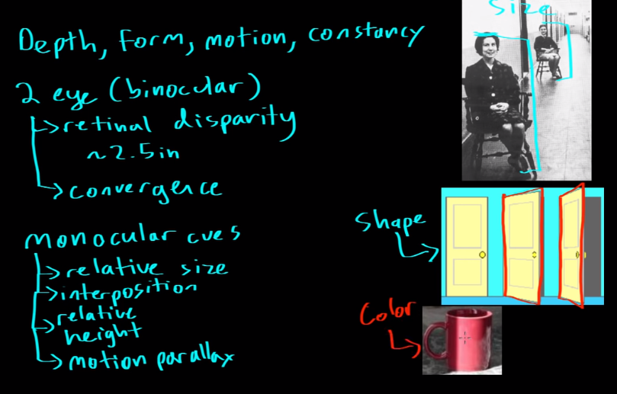

Gestalt Principles

* Ways that our brain can infer the missing parts of an incomplete picture
* **Law of Pragnanz**:Perceptual organization will always be as simple, regular and symmetric as possible

